Institute of Systems Science

National University of Singapore

MASTER OF TECHNOLOGY IN
SOFTWARE ENGINEERING

Unit 3 Examination Sample Examination Questions

Subject: Object Oriented Analysis and Design

SAMPLE SOLUTIONS

Question 1 [30 Marks]

a. Figures 1 (see page 6) [4 Marks]
Figures 2 (see page 7) [4 Marks]
Figures 3 (see page 8) [7 Marks]

Note that this question was set before we taught UML in SE Unit 3. Hence these collaboration diagrams are NOT presented using standard UML notation. However, they should give you some idea of what would be expected.

b. Use Case Descriptions - Robustness Analysis (Standard Flow Only)

These are long-form descriptions. The students are only expected to provide their answers in note form.

Creating Customer [6 Marks]

- To initiate the use case, the Customer Creator selects the Create Customer option from the CMS Main Menu. As a result of selecting this menu option, operation On Create (of CMS Main Menu) is called. This informs the Customer Controller that the user requires to create a customer by using operation Start Creation (of Customer Controller).
- To initiate the entry of customer information, the Customer Controller instructs the Customer Details Screen to be displayed and enabled for data entry by using operations Show and Enable Entry (of Customer Details Screen).
- The Customer Creator then enters the information into the screen. When all the information has been entered, the user presses the Save button. As a result operation On Entry (of Customer Details Screen) is called. This informs the Customer Controller that the information has been entered and that it needs to checked by using operation Check Customer (of Customer Controller).
- To undertake the check the Customer Controller instructs the CIF Interface by using operation Check Duplicate (of CIF Interface). The following will then occur:
  - If a customer already exists with the same Id then the Customer Controller displays an appropriate message in a Message Box by using operation Show (of Message Box). Control is then returned to the Customer Details Screen by using operation Enable Entry (of Customer Details Screen) so that the Id can be corrected by the user etc.
  - If the customer does not already exist, then the Customer Controller will proceed to arrange for the qualification of the customer, and the storage of the customer in the CIF system as follows:
    - The data will be read from the Customer Details Screen by using operation Get Details (of Customer Details Screen).
    - The data will be stored in a Customer object by using operation Store (of Customer).
    - The user name (of the Customer Creator) will be read from the User Information object by using operation Get Name (of User Information).
    - The Qualification Controller will be instructed to qualify the customer by using operation Process Qualify (of Qualification Controller). This is covered by use case Perform Qualification.
    - The Customer, user name and date will then be stored in the CIF system by using operation Save Customer (of CIF Interface).
    - Operation Get Details (of Customer) will be used to read the data from the Customer object.
  - To signify that the customer has been successfully created, an appropriate message will be displayed in a Message Box by using operation Show (of Message Box).
  - Control is then returned to the Customer Details Screen by using operation Enable Entry (of Customer Details Screen) so that more customers can be entered.
- When the user has completed creating customers, the Close button on the Customer Details Screen is pressed. As a result operation On Close (of Customer Details Screen) is called. This closes the Customer Details Screen and control is returned to CMS Main Menu.

Perform Qualification [9 Marks]

- The use case starts when operation Process Qualify (of Qualification Controller) is called.
- The Qualification Controller then displays the Qualify Customer Screen by using operation Show (of Qualify Customer Screen). The customer name and Id are then read from the Customer object by using operations Get Name and Get Id (of Customer) and displayed on the Qualify Customer Screen by using operation Display Customer (of Qualify Customer Screen).
- The Qualification Controller then instructs the CIF Interface to retrieve any the Bankruptcy List or Blacklist records that match this customer’s name or Id by using operations Get Bankruptcy List and Get Blacklist (of CIF Interface). The returned bankruptcy records are stored in a Bankruptcy List object by using operation Store (of Bankruptcy List). The returned blacklist records are stored in a Blacklist object by using operation Store (of Blacklist).
- The Qualification Controller then instructs the DB Interface to retrieve the current status of the customer’s Current Account, FITAS Account, Loan Account and Credit Card Account by using operations Get Current, Get FITAS, Get Loan and Get Credit (of DB Interface). The returned data are stored in Current Account, FITAS Account, Loan Account and Credit Card Account objects respectively by using operation Store (of each of the objects).
- The Qualification Controller then determines and processes the bankruptcy status, litigation status and blacklist status of the customer as follows:
  - The bankruptcy status is determined by reading/assessing the bankruptcy records using Get Record (of Bankruptcy List), and then the status is displayed on the Qualify Customer Screen by using operation Display Bankruptcy (of Qualify Customer Screen). In certain circumstances when multiple records are found, no status can be determined and the Bankruptcy List object is sent to the Qualify Customer Screen as a parameter of operation Display Bankruptcy. Each record is then read from the Bankruptcy List by using operation Get Record (of Bankruptcy List) and displayed. In such cases the user can select the bankruptcy status and the press the Save button to record the selection. Operation On Set Bankruptcy (of Qualify Customer Screen) is then called to record the selection.
  - The litigation status is determined by reading/assessing the bankruptcy records using Get Record (of Bankruptcy List), and then the status is displayed on the Qualify Customer Screen by using operation Display Litigation (of Qualify Customer Screen). In certain circumstances when multiple records are found, no status can be determined and the Bankruptcy List object is sent to the Qualify Customer Screen as a parameter of operation Display Litigation. Each record is then read from the Bankruptcy List by using operation Get Record (of Bankruptcy List) and displayed. In such cases the user can select the litigation status and the press the Save button to record the selection. Operation On Set Litigation (of Qualify Customer Screen) is then called to record the selection.
  - The blacklist status is determined by reading/assessing the blacklist records using Get Record (of Blacklist), and then the status is displayed on the Qualify Customer Screen by using operation Display Blacklist (of Qualify Customer Screen). In certain circumstances when multiple records are found, no status can be determined and the Blacklist object is sent to the Qualify Customer Screen as a parameter of operation Display Blacklist. Each record is then read from the Blacklist by using operation Get Record (of Blacklist) and displayed. In such cases the user can select the blacklist status and the press the Save button to record the selection. Operation On Set Blacklist (of Qualify Customer Screen) is then called to record the selection.
- The Qualification Controller then determines the Excess/Arrears status by reading and processing various details from the Current Account, FITAS Account and Loan Account objects using operation Get Details (of each object). The status is then displayed on the Qualify Customer Screen by using operation Display Excess/Arrears (of Qualify Customer Screen).
- The Qualification Controller then determines the Excessive Spending status of the customer by reading and processing various details from the Credit Card Account object using operation Get Details (of Credit Card Account).
- The Qualification Controller then determines whether the customer is Classified by using operation Get Classified (of Customer). The status is then displayed on the Qualify Customer Screen by using operation Display Classified (of Qualify Customer Screen).
- When the user has finished viewing the Qualify Customer Screen, the Accept button is pressed. This causes operation On Accept (of Qualify Customer Screen) to inform the Qualification Controller to store the qualification data by using operation Store Qualify (of Qualification Controller). To achieve this:
  - The data is read from the Qualify Customer Screen by using operation Get Details (of Qualify Customer Screen).
  - The data is stored in a Qualification object by using operation Store (of Qualification).
  - The Qual DB Interface is instructed to save the Qualification by using operation Save Qualify (of Qual DB Interface). To do this, the Qual DB Interface reads the data from the Qualification by using operation Get Details (of Qualification).
- The Qualify Customer Screen is then removed from the screen by using operation Hide (of Qualify Customer Screen). Control then returns to the caller of the use case.
Figure 1 - Solution to Question 1a
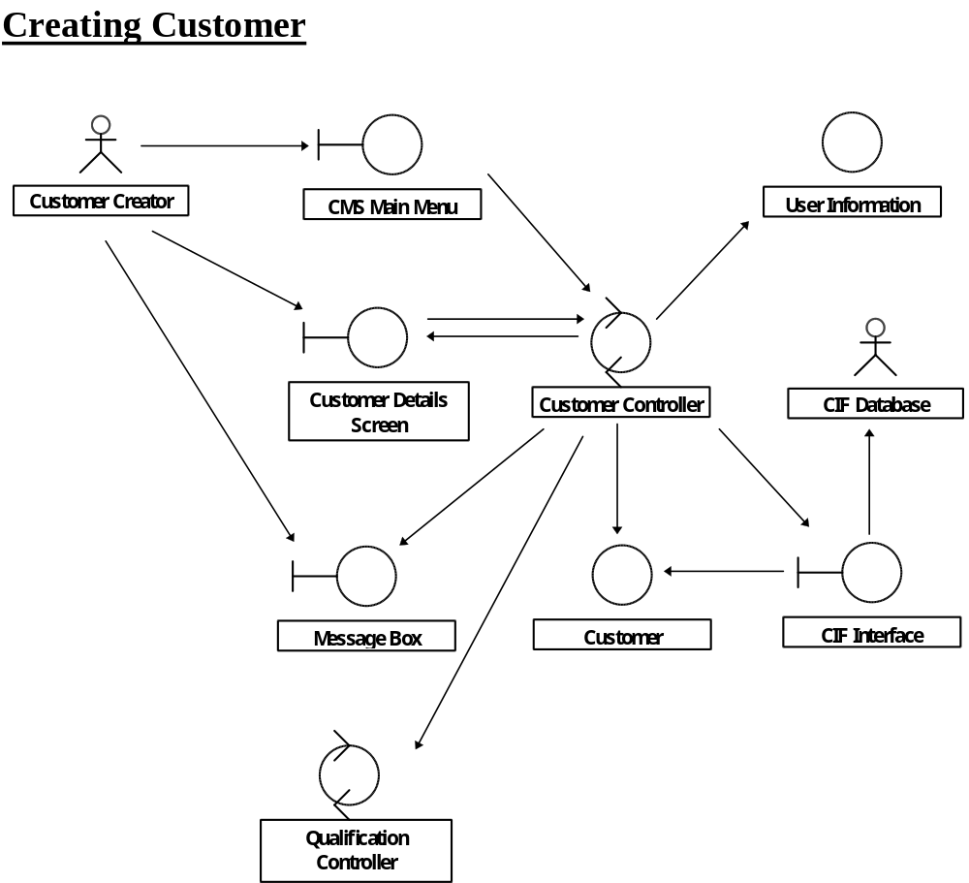
Figure 2 - Solution to Question 1a (cont.)
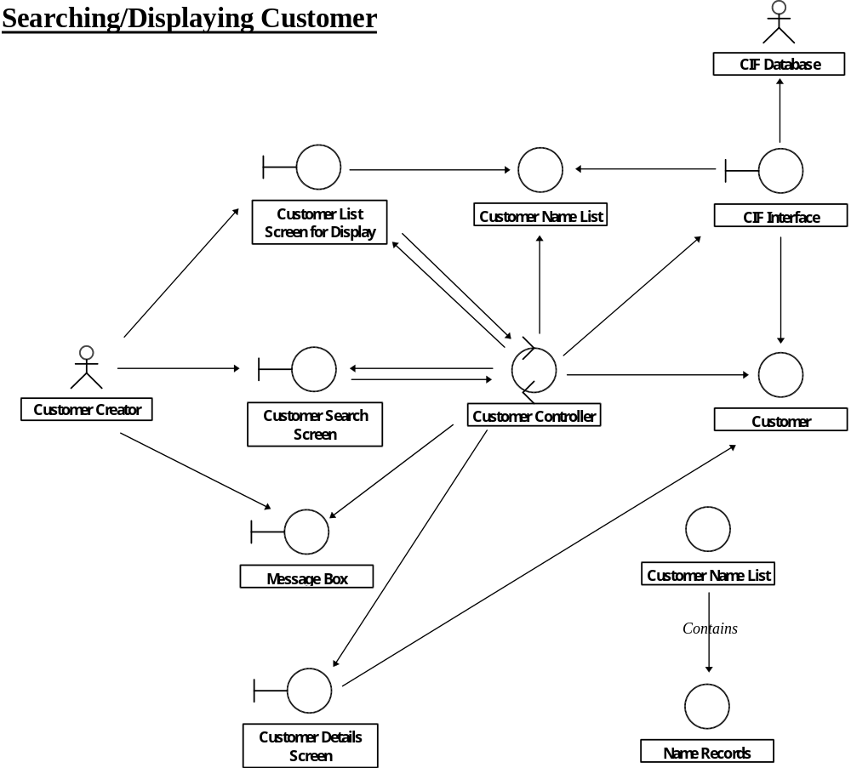
Figure 3 - Solution to Question 1a (cont.)
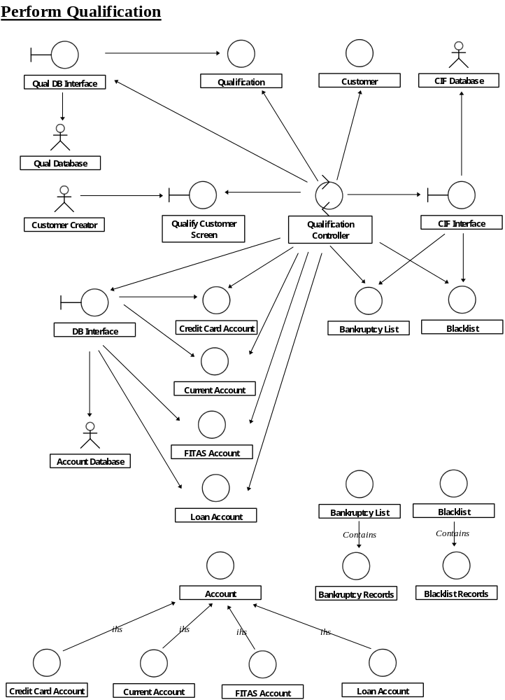

Question 2 [25 Marks]

- The use case diagrams are given in figures 4-7:
- Station Manager (fig 4)
- Presenter/Producer (fig 5)
- Listener (fig 6)
- System Administrator (fig 7)
[15 Marks]
Marking Scheme:
  - Actors: 0.5 marks per actor (up to max of 2 Marks).
  - Abstract use cases: 1 mark for each reusable abstract use case (up to a max of 6 Marks).
  - Concrete and non-reusable abstract use cases: 0.25 marks for each use case (up to a max of 7 Marks).

- See figure 8
[10 Marks]
Marking Scheme:
- 0.25 marks for each correct object (up to max of 5 Marks).
- 0.25 marks for each correct relationship (up to max of 5 Marks).

Note that figure 8 does not show any inheritance relationships. However, students will receive credit for any appropriate superclasses and associated relationships that they present.
Figure 4 - Solution to Question 2a – Manager
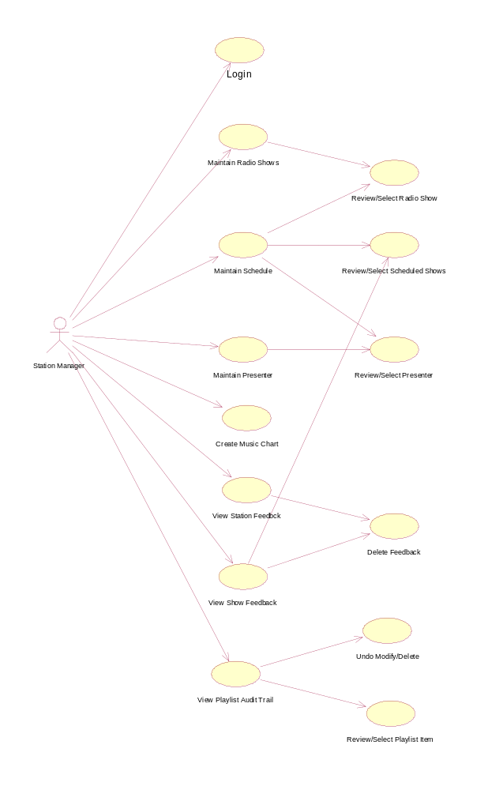
Figure 5 - Solution to Question 2a – Presenter/Producer
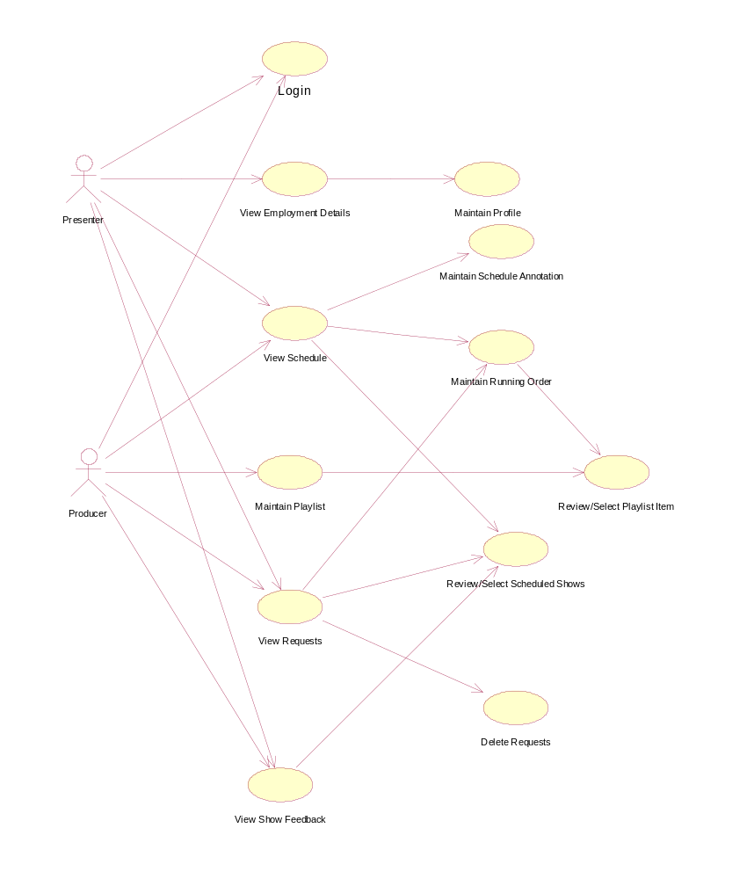
Figure 6 - Solution to Question 2a – Listener
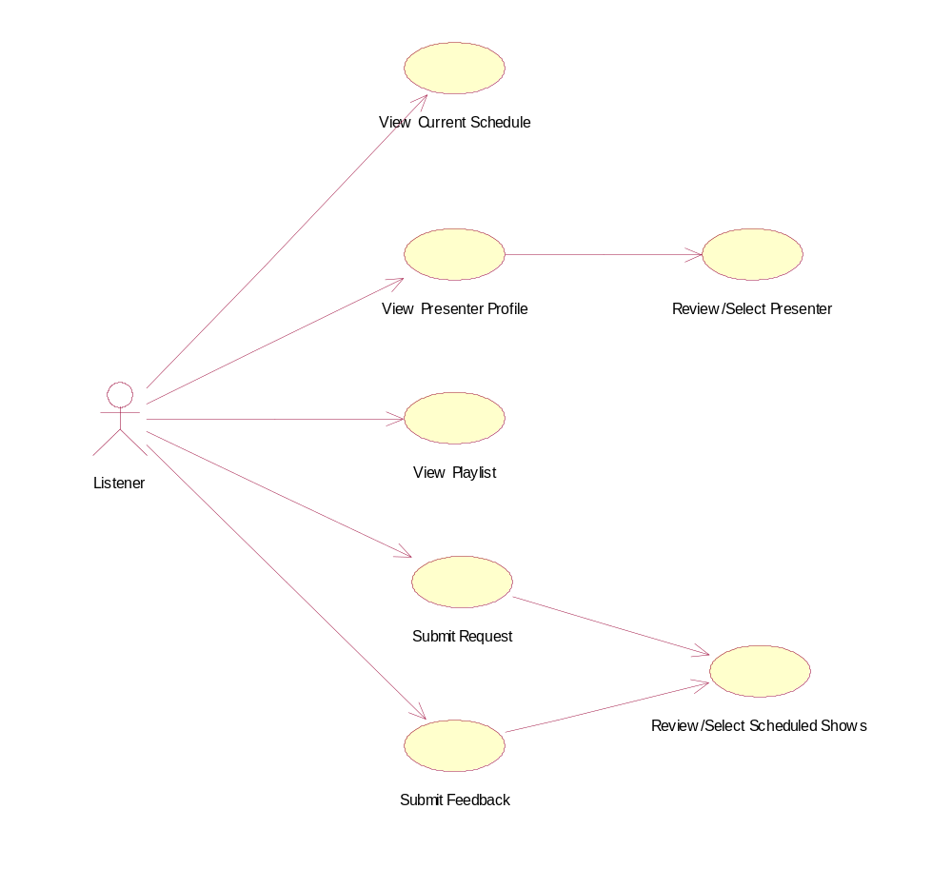
Figure 7 - Solution to Question 2a – System Admin

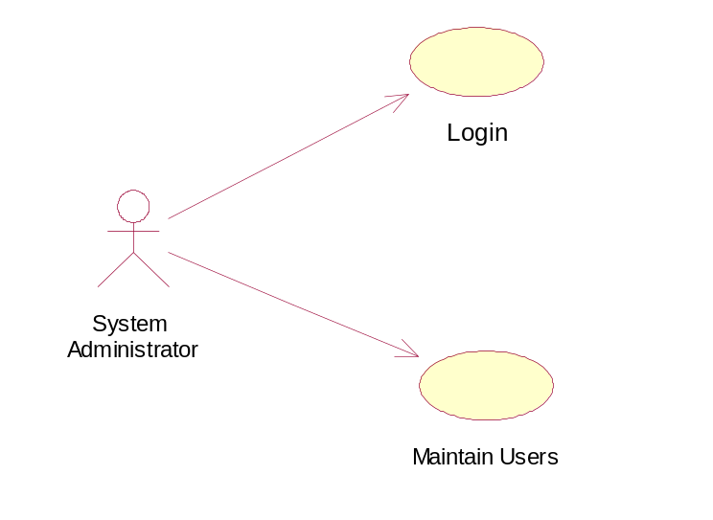
Figure 8 - Solution to Question 2b
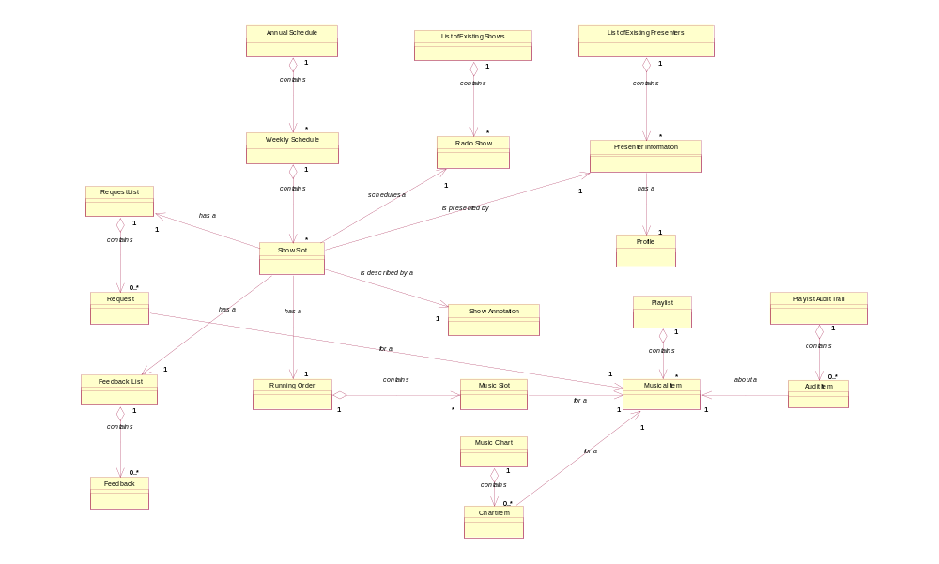
Question 3 [14 Marks]

- The critical alternate events or exceptions are:
  - On Step 5b, if the order details are not complete or incorrect, the AO then sends notification back to the shipping department seeking clarification.
  - On Step 5d, if the invoice generated is not correct, then the AO regenerates the invoice.
  - On Step 5e, if the customer fails to make payment within the stipulated time (as mentioned in the invoice), the AO sends a reminder to the customer.
  - On Step 5e, if the customer fails to make the payment within the stipulated time (as mentioned in the reminder), the AO sends a legal enforceable notice to the customer. In this case the company would also blacklist the customer for further transactions.
  - On Step 5g, if the payment received differs from the payment to be made then the customer is notified.

Marking Scheme
- 1 mark for each exception identified. Full marks will be given even if the then identification is limited to the exception condition.
- 0.5 marks will deducted for each incorrect exception identified or correct exception sequenced in the wrong place.
(4 Marks)

- At the minimum six (6) system level functional test cases would be required to test this use case. These are:
  - Test Case 1: Steps 5a → 5b → 5c → 5d → 5e → 5f → 5g → 5h
  - Test Case 2: Steps 5a → 5b → Exception 1
  - Test Case 3: Steps 5a → 5b → 5c → 5d → Exception 2
  - Test Case 4: Steps 5a → 5b → 5c → 5d → 5e → Exception 3
  - Test Case 5: Steps 5a → 5b → 5c → 5d → 5e → Exception 3 → Exception 4
  - Test Case 6: Steps 5a → 5b → 5c → 5d → 5e → 5f → 5g → Exception 5

Marking Scheme
- 1 mark for each test case sequence steps identified correctly.
- Only 0.5 marks for each test case will be awarded if the steps do not include exceptions or exceptions are placed in the wrong sequence.
(6 Marks)

- Main points of critique are:
- All interactions are limited to just one boundary object ‘billing & collection page’.
- There is no control object in the design, and all the control operations have been assigned to the ‘billing & collection page’ boundary object. This means that ‘billing & collection page’ is effectively serving the purpose of both boundary & control objects.
- It can be inferred from this design that we have thick client 2-tier application.
- The diagram very clearly depicts that the distribution of behavior is heavily skewed to the single boundary object, with the remaining objects having very little to do.
- Concentrating so much behavior into one object creates a classic ‘single point of failure’ situation and a very large and complex object. This can lead to difficulties in incorporating changes and maintenance

Marking Scheme
- Broadly the above points would be looked into. The direction of thinking would be considered rather than actual wording of the answer.
(4 Marks)
Question 4 [20 Marks]

Not Available.
Question 5 [6 Marks]

- A component diagram (1 Mark) is appropriate. The software driver is represented as a component with multiple interfaces (1 Mark) with other parts of the system being components that make use of specific interfaces. Such component diagram is categorized as a part of the Development View (1 Mark). Other approaches would be considered on their merits.
(3 Marks)

- An object diagram (1 Mark) is appropriate for capturing the composition of the process instances and thread instances. Class diagram is not appropriate as it is not able to capture the specific combination of process/thread instances. Such object diagram is categorized as a part of the Process View (0.5 Mark). An interaction diagram (either collaboration or sequence) (1 Mark) is appropriate for capturing the interaction among the process/thread instances. Such interaction diagram is categorized as a part of the Process View (0.5 Mark).
(3 Marks)
Question 6 [10 Marks]

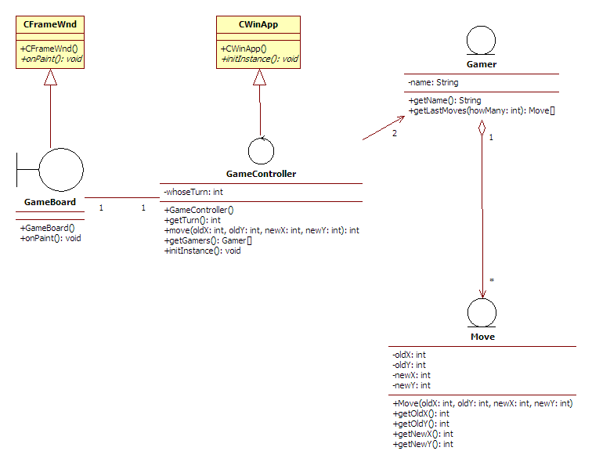

Marking Scheme
- GameBoard inherits CFrameWnd (1 Mark)
- GameBoard overrides onPaint() (0.5 Mark)
- CWinApp inherits CWinApp (1 Mark)
- CWinApp overrides initInstance() (0.5 Mark)
- Gamer and Move are kept in tact (1 Mark)
(4 Marks)

GameController.java:
public class GameController extends CWinApp {

private GameBoard gameBoard = null;
private Gamer gamers[]= new Gamer[2];
[. . .]
}

GameBoard.java:
public class GameBoard extends CFrameWnd {

private GameController gameController = null;
[. . .]
public GameBoard(GameController gameController) {
this.gameController = gameController;
}
[. . .]
}

Gamer.java
import java.util.ArrayList;

public class Gamer {
private ArrayList moves = new ArrayList();
[. . .]
public void addMove(Move aMove){
moves.add (aMove);
}
[. . .]
}
(6 Marks)

Question 7 [30 Marks]

- The following is an example of a critique of the Design. Any answer format is acceptable, it is the various arguments that will be verified. Additional valid points, in case any are found, will be awarded 1-2 marks, subject to a cap at the maximum mark for this question.

  - List, TextField, Dialog, TextListener and ActionListener belong to the AWT API.
--1 Mark

  - The ContactSelector boundary object is split into two classes:
    - the ContactSelectBox dialog, which is the AWT interfaces class
    - the ContactSelector, which is a small controller
The reason for the split is that the Analysis model class had functionality that can only in part be found in the AWT framework. So the "passive" GUI components are separated out into the ContactSelectBox dialog, while the control logic that responds to user actions is encapsulated into ContactSelector
-- 2 Marks
  - The two Listener objects (ContactSelectTextListener and ContactSelectListListener) are implementations of the AWT TextListener and ActionListener interfaces respectively, and are needed in order to handle the user actions.
-- 2 Marks

  - However, they are small objects that delegate the actual processing to the ContactSelector controller. For instance, the TextListener handles events that populate the list box, but it has no direct control over the list box itself.
-- 2 Marks

  - The aggregated components of the Dialog (the List and TextField objects) are instantiated by the Dialog itself, as is the norm with aggregation.
-- 2 Marks

  - As a result, the ContactSelectBox dialog instantiates the listeners associated with its aggregate components. This is the reason why the ContactSelectBox constructor must receive a reference to the ContactSelector: it must pass it to the listener objects, as they need to invoke the control logic to ContactSelector upon a user event.
-- 2 Marks

  - In addition, the ContactSelectBox must provide the getListBox() method so that the ContactSelector may get a reference to the List component in order to repopulate it. Unless this method is provided, the List component is private to the dialog.
-- 2 Marks

  - In order to instantiate ContactSelectBox, we must provide a Frame object (required by the AWT Dialog class, as shown in the class diagram). This is the reason why the ContactManager needs to provide a getMainWindow() method, which provides a reference to the application's main window (a Frame instance).
-- 2 Marks

  - The Listener classes implement the Observer pattern, and the split of ContactSelector supports the MVC model. One could also argue that ContactSelector is a Facade for the remaining interface classes
-- Bonus 1-2 Marks

- The following is an implementation of ContactSelector:

import java.awt.*;
import java.util.*;

public class ContactSelector {

private ContactManager contactManager; //-+
private ContactList contactList; // | 2
private ContactSelectBox selectBox; //-+
private Vector selectableContacts; // 1

public ContactSelector (ContactManager contactManager) {
this.contactManager = contactManager;
contactList = contactManager.getContactList(); // 1
Frame mainWindow = contactManager.getMainWindow (); // 1
selectBox = new ContactSelectBox (mainWindow, this); // 1
selectBox.setVisible (true);
}

public void setChoices (String userText) {
java.awt.List listBox = selectBox.getListBox (); // .5
listBox.removeAll (); // .5
int count = contactList.getSize(); // .5
selectableContacts = new Vector (); // .5
for (int i = 0; i < count; i++) { // .5
Contact c = contactList.getElement (i); // 1
if ((c.getName().startsWith (userText)) || //-+ 2
(c.getSurname().startsWith (userText))) { //-+
selectableContacts.add (c); // .5
listBox.add (c.getDisplayName()); // 1
}
}
}

public void selectContact (int index) {
Contact c = (Contact) selectableContacts.get (index); // 1
contactManager.setSelected (c); // 1
}

}
-- 15 Marks (marks shown in comments in the code):
3 for attributes
3 for constructor
7 for setChoices
2 for selectContact

